Taekwondo Uniforms

Students who study Taekwondo long enough to reach the rank of 6th Kub (Green Belt) will have the option to wear a Blue colored Taekwondo uniform for all regular class sessions. They come with our school logo and are made from an upgraded material from the regular student uniform.

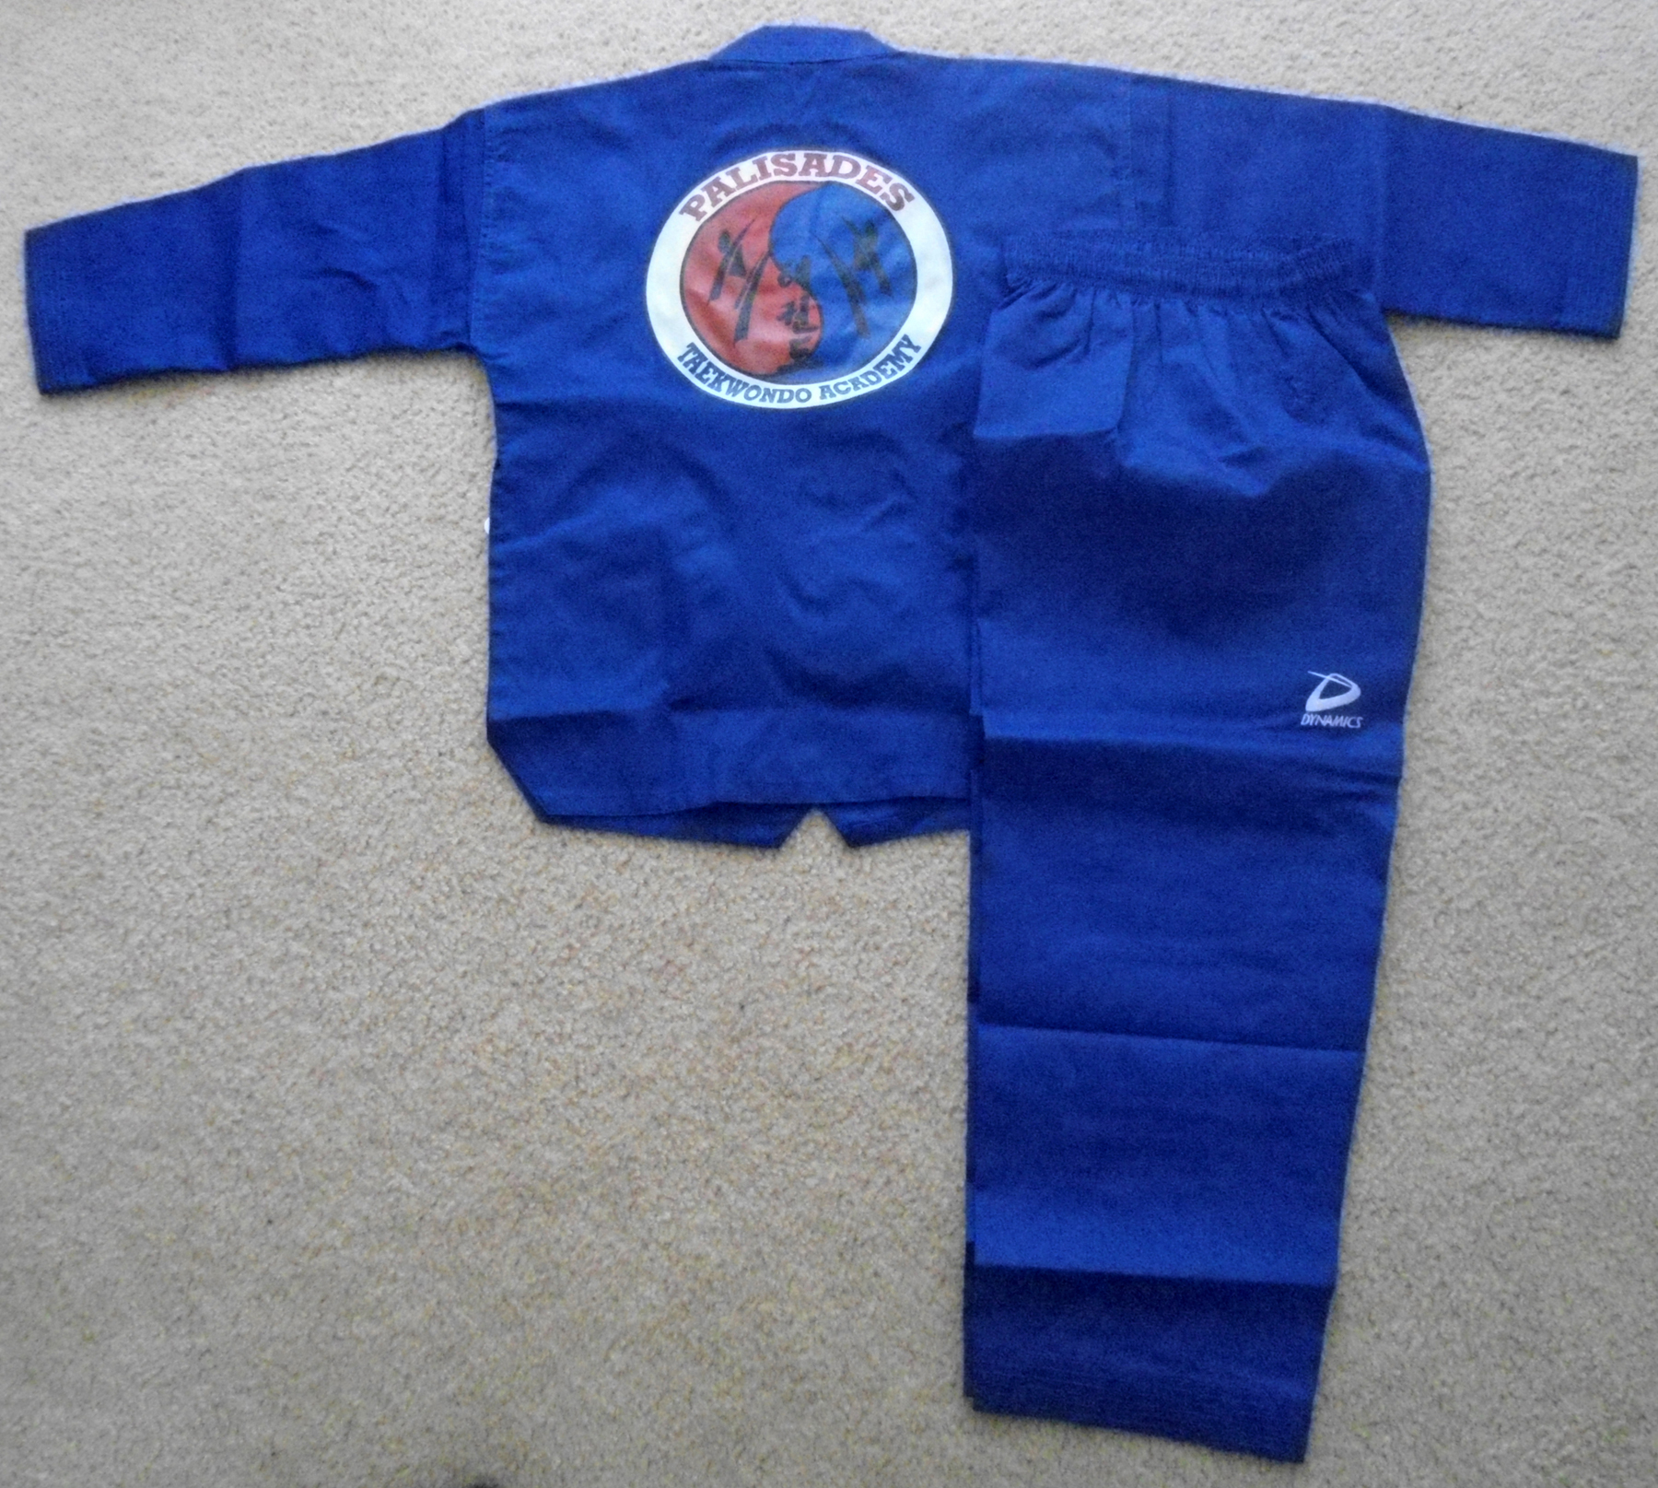
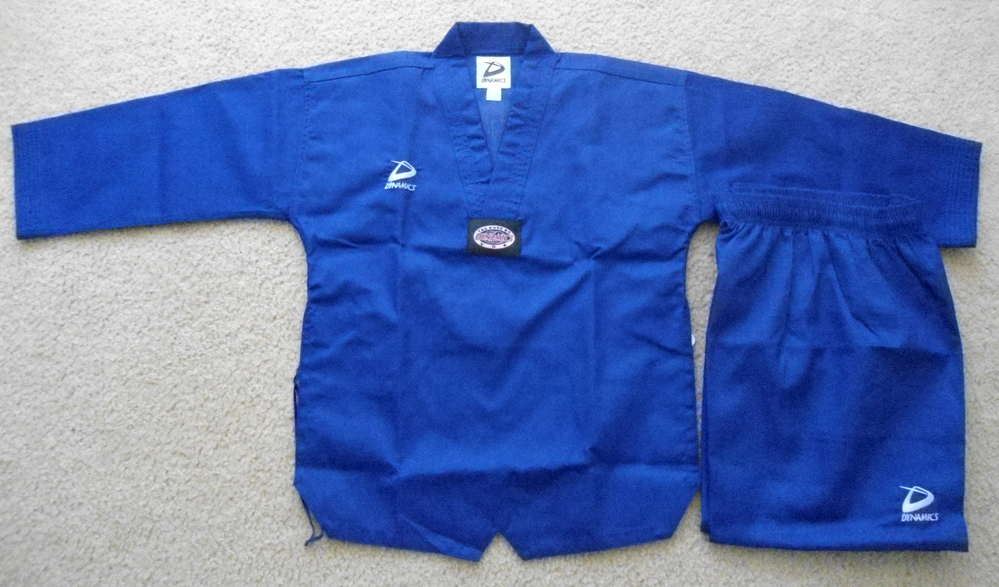
The uniforms are special ordered and typically take 1 week to arrive. The cost per uniform is $50.
Please see Master Shea to place an order.

