HOW TO TIE YOUR BELT
  1. Find the center of the belt and place it slightly below your navel.  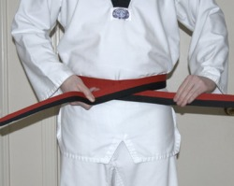  3. Take one end and lay it flat on top of the other end, and pull the belt comfortably tight around your waist.  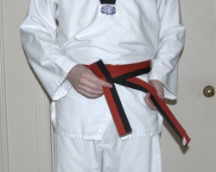  5. Readjust the tightness to your comfort level, then take the top end you just pulled through and point it downward.  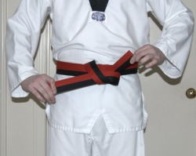  7. Take the side pointing downward and pull that end of the belt up through the loop. | 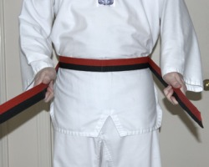  2. Wrap the belt around your waist, bringing both ends to the front, making sure both sides are even.  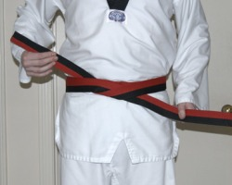  4. Take whichever side you placed on top and bring it up from underneath BOTH belt rings circling your waist.  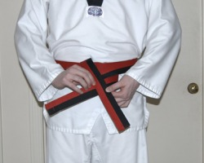  6. Take the other end and form a loop by bringing that side behind the top end that you just pointed downward.  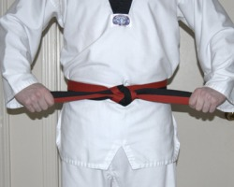  8. Pull both ends to the side, tightening your knot. You are now done!

