Hello Taekwondo Parents and Students, September 15, 2012

I have created this letter to help familiarize you with some of the training and safety equipment used during Taekwondo class. Sparring class is held during the regular session on Fridays. Light contact to the body only is permitted for ages under 12 years old. For those students who are interested, please choose a sparring gear set from this letter. All Palisades Taekwondo Students receive 20% off of retail prices on all equipment. Some gift ideas to help your Taekwondo student train at home are listed below. Please feel free to contact Mr. Shea if you have any questions with sizing or to place an order at 704 491-5740. Thank you.
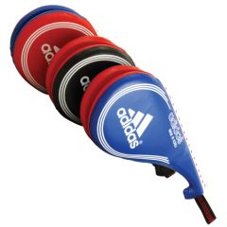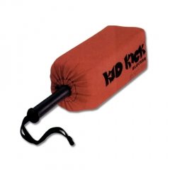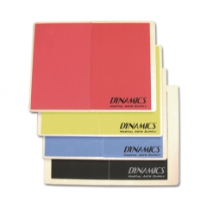

Adidas Taekwondo Target Soft Foam Blocker Re-breakable Board
$26.00 (special $20) $24.00 $25.00
Great for practicing kicks Hone defensive skills Improve confidence and focus

Tae Kwon Do Sparring Gear Starter Set (Package A)

Cloth Forearm Guard $12.95 20% discount $10.36
Cloth Shin-Instep Guard $14.95 20% discount $11.36
Dynamics Chest Guard $39.95 20% discount $31.96
Shock Doctor Pro Mouthguard $9.95 20% discount $7.96
Mouth Guard Case $2.95 20% discount $2.36
Male/Female Groin Cup $16.95 20% discount $13.56
Headgear $33.95 20% discount $27.16
$131.65 $104.72 (Sale Price)
(Include Taekwondo Bag)
Large Tae Kwon Do Bag $39.95 20% discount $31.96
(Comes in Red or Blue) $171.60 $136.68 (Sale Price)

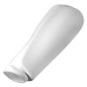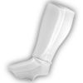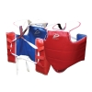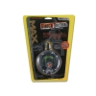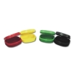
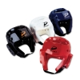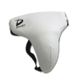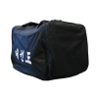

Complete Dynamics Tae Kwon Do Sparring Gear Set (Competition)

Dynamics Hand Protector $29.99 20% discount $23.99
Vinyl Forearm Guard $24.95 20% discount $19.96
Vinyl Shin-Instep Guard $32.95 20% discount $26.36
Dynamics Chest Guard $39.95 20% discount $31.96
Shock Doctor Pro Mouthguard $9.95 20% discount $7.96
Mouth Guard Case $2.95 20% discount $2.36
Male/Female Groin Cup $16.95 20% discount $13.56
Headgear $33.95 20% discount $27.16
$191.64 $153.31 (Sale Price)
(Include Taekwondo Bag)
Large Tae Kwon Do Bag $39.95 20% discount $31.96

$231.59 (Retail) $185.27 (Sale Price)

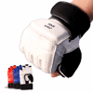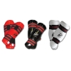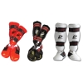

Blue Colored Taekwondo Uniforms are permitted for those students who have achieved the rank of Green Belt or higher. Orders take approximately 1 week to receive $50.00

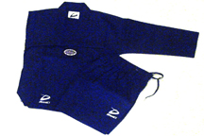

Other Martial Arts equipment is available ask Master Shea for a catalog to take home.

