Taekwondo at the YMCA After School
Program at Griggs Road Elementary

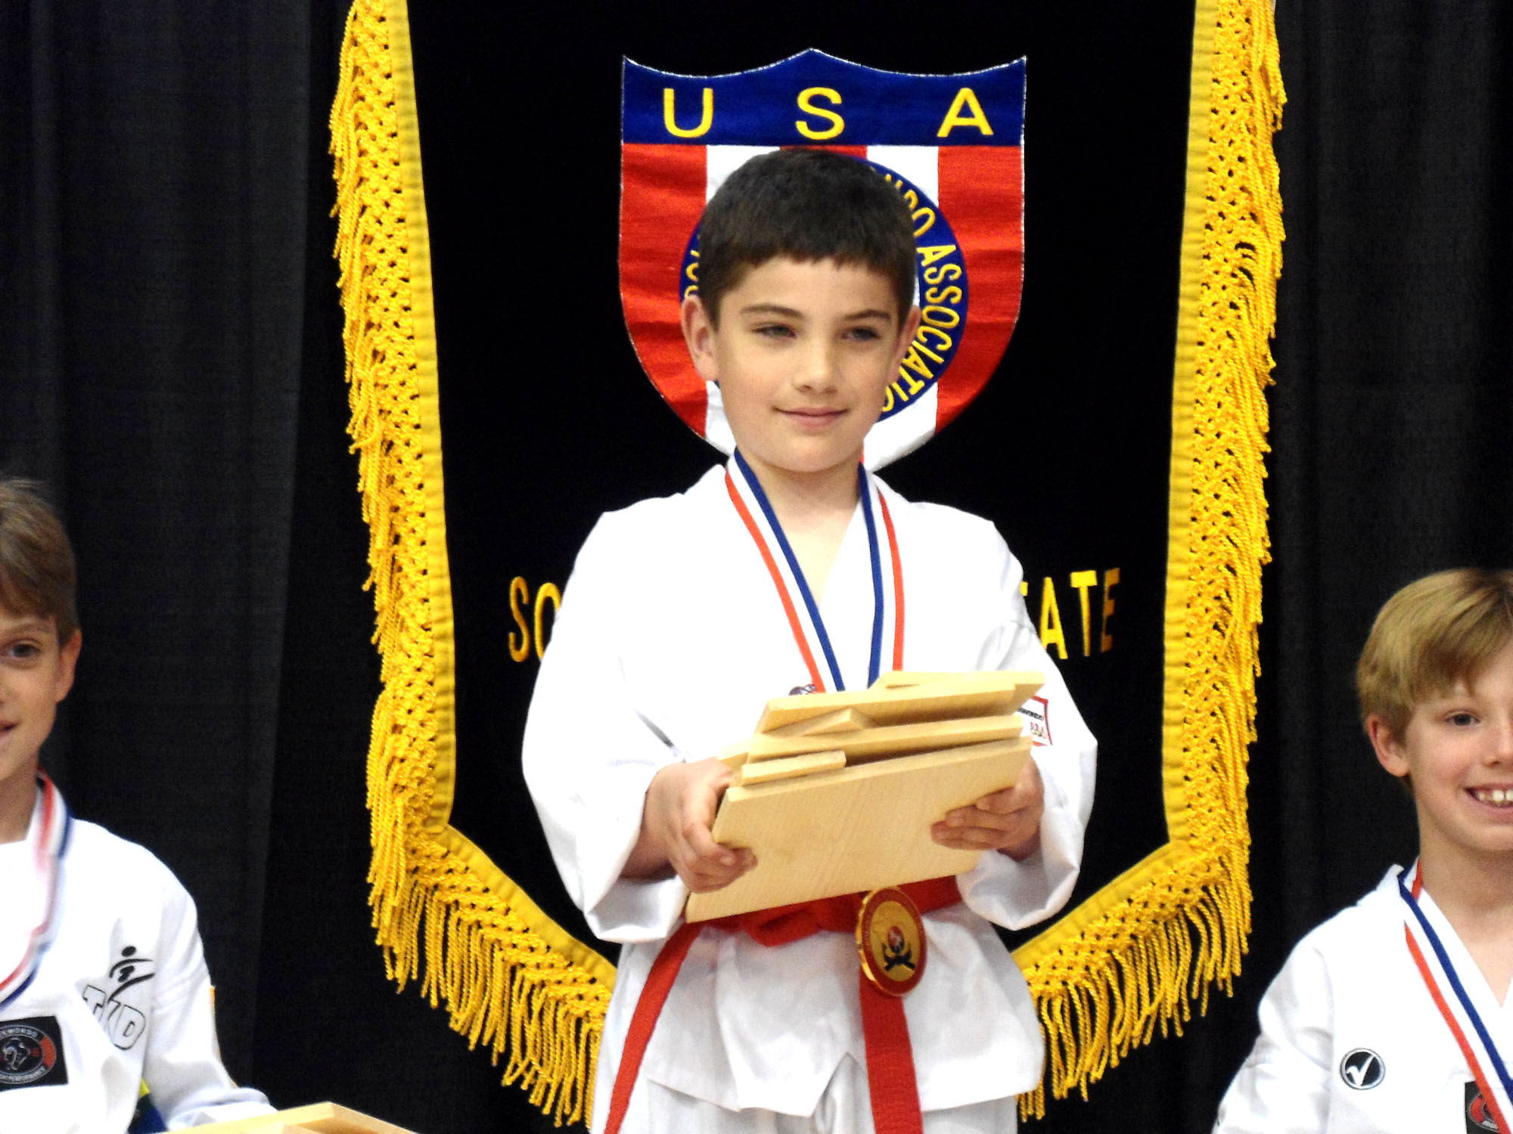
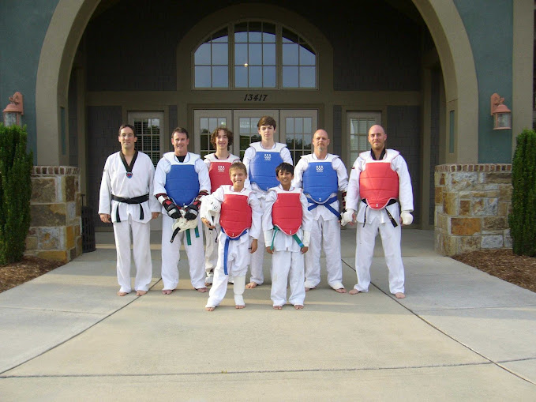
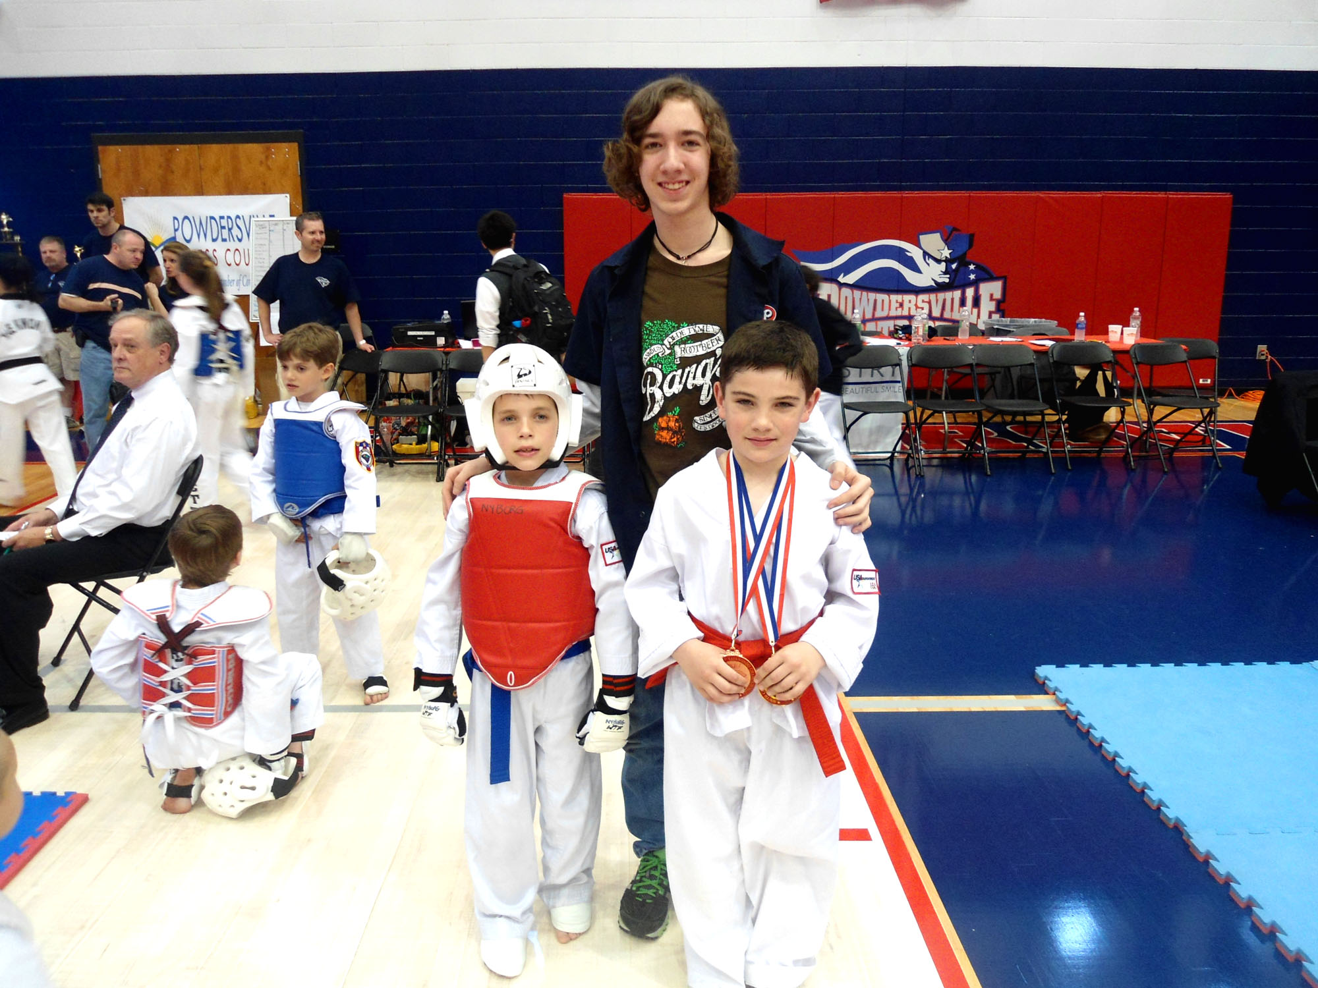
Children can experience a free trial lesson on Tuesdays or Thursdays between 2:20 and 3:10 PM
Classes begin on Tuesday September 2nd 2014 (Open enrollment all year!)
The Lake Wylie YMCA is proud to be a part of the World Taekwondo Federation (WTF)
Belt Rank earned at our Academy is honored in every state and in 205 member nations around the world!

Benefits
Traditional Martial Arts training builds character and enhances self- esteem
Improved mind body connection that lasts a lifetime
Students learn the same Taekwondo as practiced by our United States Olympic Team
Learn how to handle bullies and treat others with Respect
The Lake Wylie YMCA Taekwondo program offers a disciplined, supportive learning environment
Each student receives personal attention and guidance from Master Shea (5th Degree WTF Black Belt)

Class Schedule
YMCA After-school Program at Griggs Road Elementary
Tuesdays and Thursdays 2:20-3:10 PM (Session 1) 3:30-4:20 (Session 2)

Tuition
YMCA After School Members $64 per month, Non-members $69 per month
No Registration Fee, Uniform $25
FREE TRIAL LESSON AND EVALUATION
Convenient monthly billing cycle

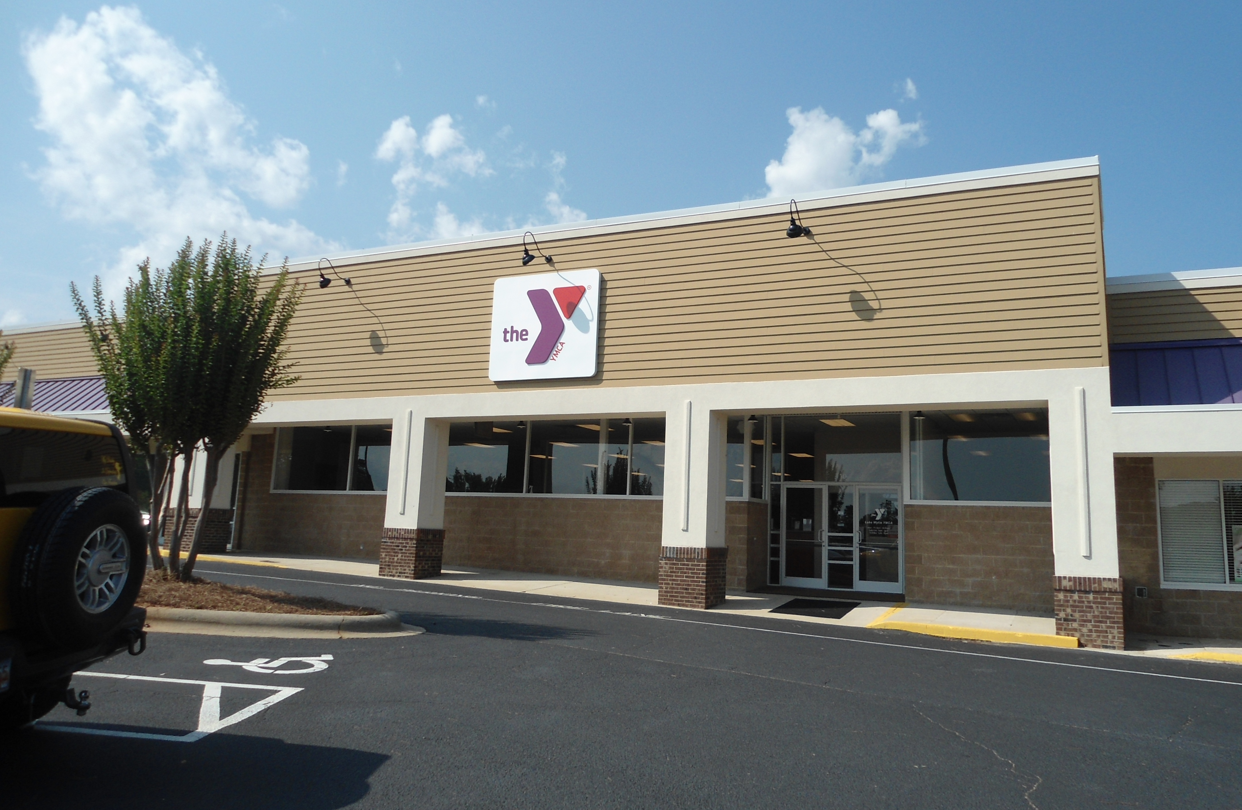


To Enroll your child, please submit the registration form to your YMCA after school representative or send to Master Shea directly at: info@palisadestkd.com

YMCA Taekwondo Program at Griggs Road Elementary School
Registration Form

Dear Parents,

We wish to welcome you and your child to The YMCA After School Taekwondo Program led by Master Michael Shea of Palisades Taekwondo Academy. Please fill out the form below and return it to Master Shea or your YMCA after school representative.

Child’s Name________________________________________________Age______________
Parent’s Names________________________________________________________________
Telephone Numbers (home)_________________________(Cell)________________________
Address ______________________________________________________________________
______________________________________________/ Zip___________________
School________________________________________________ Grade________________
Is your child a current member of YMCA After School Program? Yes_____ No____
Tuition for YMCA (after school) members is $64 per month (Attend Session 2)
Tuition for Non-Members is $69 per month (Attend Session 1)
Payment Information
Credit/Debit Card Number _________________________________________
Name as it appears on the card ______________________________________
Expiration Date __________________________________________________
Billing Address ___________________________________________________
Email Address ____________________________________________________
Tuition payments are charged at the first of each month. A one time uniform fee of $25
will be charged on the first month that a student attends class.
Parent’s Signature______________________________________ Date_________________
Thank you,
Master Michael Shea
Palisades Taekwondo Academy
info@palisadestkd.com
704-491-5740


